Outpatient Radiology Worklist MPage

**Prefmaint Settings:**

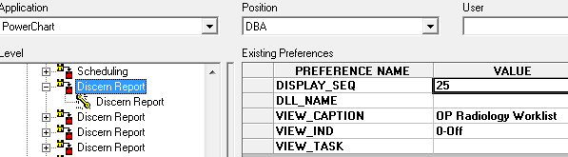

REPORT_NAME: <url>http://159.140.229.9/mpage-content/p1345.chla_ca.cernerasp.com/custom_mpage_content/Chla_eApps_Static_mPages/OPRADWLv2/PRODQASWITCH.html

**Positions the MPage is available for:**

|  |  |
| --- | --- |
| Ambulatory Administrator OP | Physician - HemOnc |
| Ambulatory Administrator OP Propose | Physician - HemOnc Pilot |
| Anesthesia Application Administrator | Physician - Hospitalist Medicine |
| DBA | Physician - Infectious Diseases |
| Nurse Practitioner | Physician - Medical Genetics |
| Nurse Practitioner OP | Physician - Neonatologist |
| Nurse Practitioner Peri-Op | Physician - Nephrology |
| Patient Access 2 | Physician - Neurology |
| Patient Access 3 HemOnc | Physician - Neuropsychology |
| Patient Access 3 OP | Physician - Neurosurgery |
| Patient Access 3 OP - NoDelete | Physician - Ophthalmology |
| Patient Access 3 OP Propose | Physician - Orthopaedics |
| Physician | Physician - Otolaryngology |
| Physician - Acute | Physician - Pain & Palliative Care |
| Physician - Adolescent Medicine | Physician - Pediatrician |
| Physician - Allergy/Immunology | Physician - Plastic Surgery |
| Physician - Anesthesiologist | Physician - Psychiatry |
| Physician - Cardiologist | Physician - Pulmonology |
| Physician - CT Surgery | Physician - Rehab Medicine |
| Physician - Dermatology | Physician - Resident OP |
| Physician - Endocrinology | Physician - Rheumatology |
| Physician - Fellow | Physician - Surgeon |
| Physician - Fellow Old | Physician - Urology |
| Physician - Gastroenterologist | Physician Advisor |

**MPage Screenshots:**

Outpatient MPage displayed when Outpatient link is clicked & INPATIENT for the same

**NEW ORDERS**

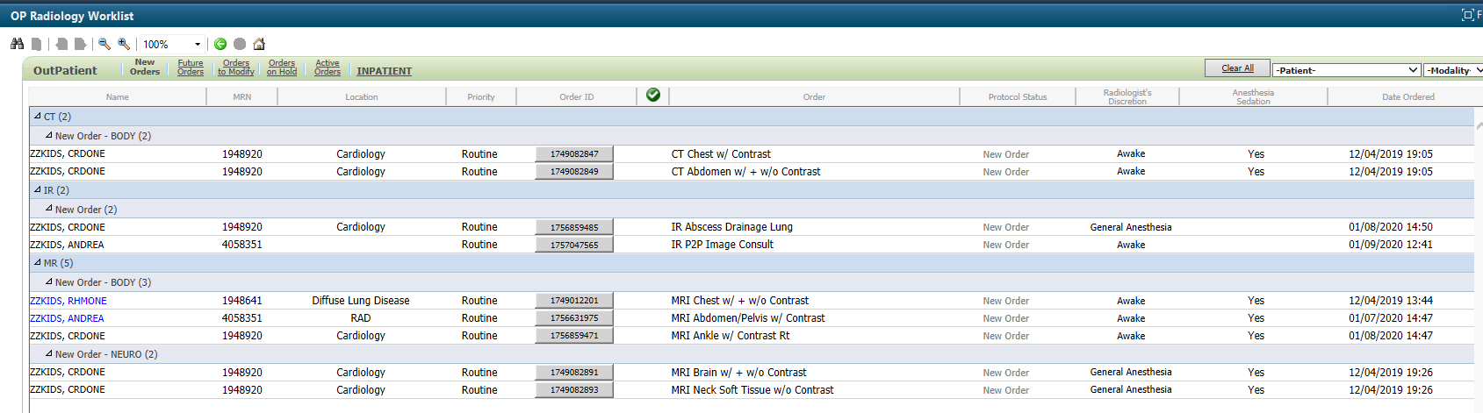

**FUTURE ORDERS**

